21.78: a) 20.0 g carbon 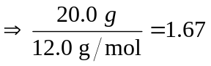mol carbon 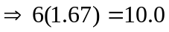 mol electrons This much charge is placed at the earth’s poles (negative at north, positive at south), leading to a force:
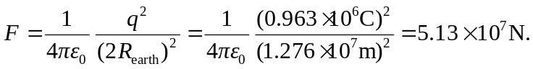
b) A positive charge at the equator of the same magnitude as above will feel a force in the south-to-north direction, perpendicular to the earth’s surface:
